**Article ID:** [4219] Glassware pitting and scratching

**Article Name:** Glassware pitting and scratching

**Topic Location:**  Dishwasher / Usage / Poor results

**Metadata:** scratches

**Related Articles:**

**Related Questions:**

PNC

DIY

Safety

Link

Email

Book Engineer

Multimedia

Brand

**Article Content:**

**WSS**

Glass pitting and scratching is caused by a combination of the glass, heat and detergent. You should therefore always use a special glass programme. Also refer to the instructions of the detergent manufacturer.

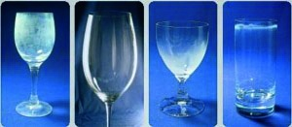

http://services.electrolux-medialibrary.com/bild.php?src=ehppdb-pictures/G/B/JPEG/PSGBDL140G002006.jpg